Maracine Florin - Claudiu

#### Address: Str.1 Decembrie 1918 nr.117 bl.B1 sc.2 et.4 ap.46 Jud.GL Mun.Tecuci Romania

**Mobile:**  +40739821940

**Email: [maracineflorinclaudiu1@gmail.com](mailto:maracineflorinclaudiu1@gmail.com)**

**Date of Birth:** 26/03/1993 (Age 27) 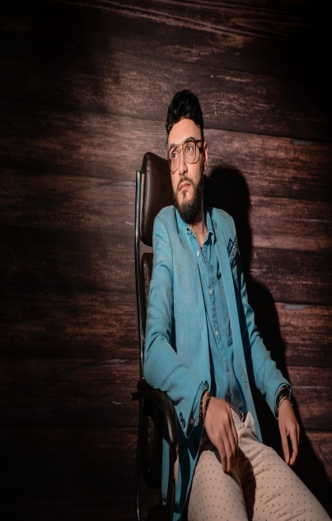

**Nationality:** Romanian

**Passport:** Romanian

**Marital Status:** Single

**Language Skills:** Fluent English, Fluent Italian,

Conversational Spanish

**Profile**

Very customer focused and with high standards at all times, with an enthusiastic and ambitious attitude, high volume experience, committed and determined.

Organized and efficient Entertainment host focused on creating a positive travel experience for all passengers. Brings in-depth knowledge of the Cruise industry, along with superb problem solving and conflict resolution capabilities.

Meticulous at juggling multiple tasks and working under pressure. Broad industry experience.

Full of energy, absolutely love interacting with guests!!!

**Key Skills**

**Creative problem solver**

**Exceptional communication skills**

**Strong client relations**

**Safety management**

**Global travel**

**Multitasking skills**

**Written and oral communication skills**

**Customer service specialist**

**Friendly**

**Expert problem solver**

**Time management**

**Passion for travel**

**Energetic and enthusiastic**

**Natural leader**

**Career History**

**Bartender**

**City Grill, Bucharest, Romania**

# April 20, 2011- October 30, 2012

**Responsibilities:**

Prepare alcohol or non-alcohol beverages for bar and restaurant patrons. Interact with customers, take orders and serve snacks and drinks. Assess customers’ needs and preferences and make recommendations. Plan and present bar menu. Check customers’ identification and confirm it meets legal drinking age. Restock and replenish bar inventory and supplies. Stay guest focused and nurture an excellent guest experience. Comply with all food and beverage regulations

# Luxury Sales Assistant

**British Fashion House, London, United Kingdom**

# February, 2013-March, 2015

**Responsibilities:**

**Serving customers at the sales counter. Offering face to face advice to customers on the stores products. Maximising store revenue by suggesting upgrades, insurance and add-ons to customers. Processing returns and refunds as required in line with company procedures. Occasionally being responsible for the stores security including being its key holder. Using the stock management system to log, check, locate and move stock both in and out of the store. Responsible for the daily management of the till in the absence of the senior members. Ensuring that all areas are clean and adhere to the company’s clear floor policy and Health and Safety requirements. Making sure that any item which is removed from a display column is replaced immediately after a sale. Handling customer complaints in a calm manor. Managing cash and payment systems in accordance with company procedures and policies.**

**Wedding Photographer & Videographer/editor**

# Dream Weddings, London, United Kingdom

**May, 2015-December 2017**

**Responsabilities:**

**Photograph event in a professional manner. Provide my skills and experience to produce photographic memories that will last a lifetime. Proficient in photographic editing software to produce stunning high quality images. Produce an end product of a high-end quality. Maintain a great rapport and professional relationship with client throughout. Gain trust with my clients for future photography needs. Capture timeless photos under any weather condition. Perform office duties and reply to emails in a timely manner. Maintain invoices and deposits on a daily basis. Willingness to accept new challenges. Meeting and delivering beyond expectations of client.**

# Entertainment Host

**Carnival Cruise Lines – Monaco, France**

# May, 2018- April, 2019

**Responsibilities:**

Provided an elevated customer experience to generate a loyal clientele. Ensured superior customer experience by addressing customer concerns, demonstrating empathy and resolving problems on the spot. Ensured Daily Fun times were made without mistakes. Hosted Games shows as well as numerous activities on the ship. Comedy club manager onboard. Ensured guests were constantly greeted with energy, and warm smile.

**Education**

**2013-2016 – UK COLLEGE OF BUSINESS AND COMPUTING**

**2016-2017 – Tourism and Hospitality Diploma**

**Leisure Activities**

Travel, Reading, Team sports, Tech Hobbies, Puzzles, Social Hobbies, Art, Computer Games, Cooking, Writing